**Storage of the data:**

The passwords and usernames added by teachers were stored in file and then it was accessed by the teacher .any changes or modifications done to the data was automatically modified in the stored file. The data will be stored in notepad file named student details. I prefer this method over database because accessing file system is more easily compared to database as once large data gets stored. Since this is attendance management system, more data will be stored so it is easy to use file system because it is lighter alternative. Also data migration is an easy process when it comes to files. And I learned it is good to use file system instead of database when it comes to usage of multiple users and when large data needs to be stored.[1]

**Table that displays the registered data in teacher's main account page:**

I used j table to display the registered information in a tabular form in the teacher account page. The stored information was retrieved from the file and was displayed in a tabular form. In the total three tables were used.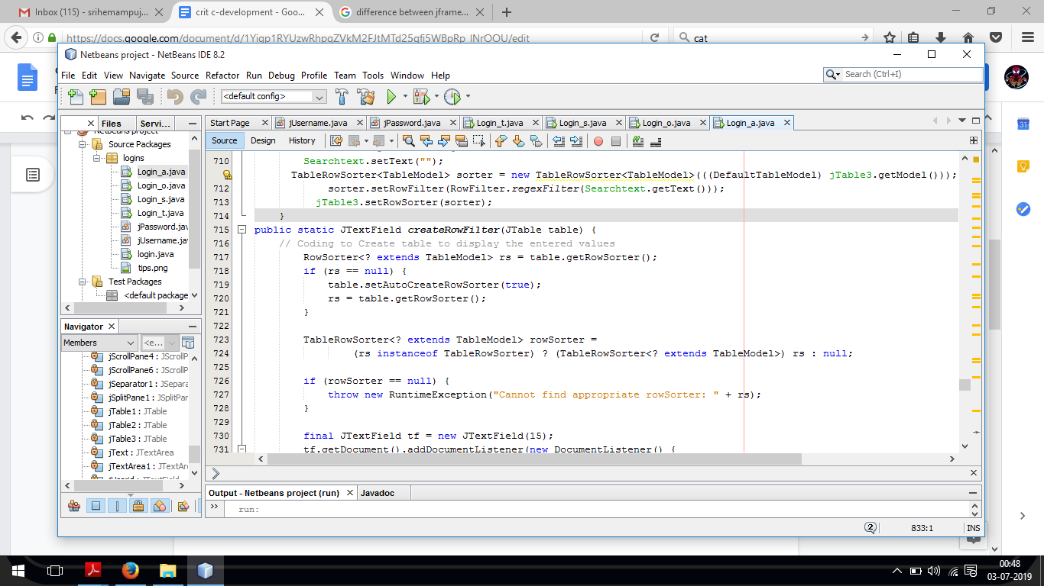

*Figure 3: shows the source code of all the tables used in the teacher’s account page.*

Since only two teacher accounts were needed in which one was for IB DP coordinator (the client) and the other one was for my computer science teacher, two objects were created in the main program. If more teacher account is needed then the programme will have to manually create more objects and do modification in the coding.

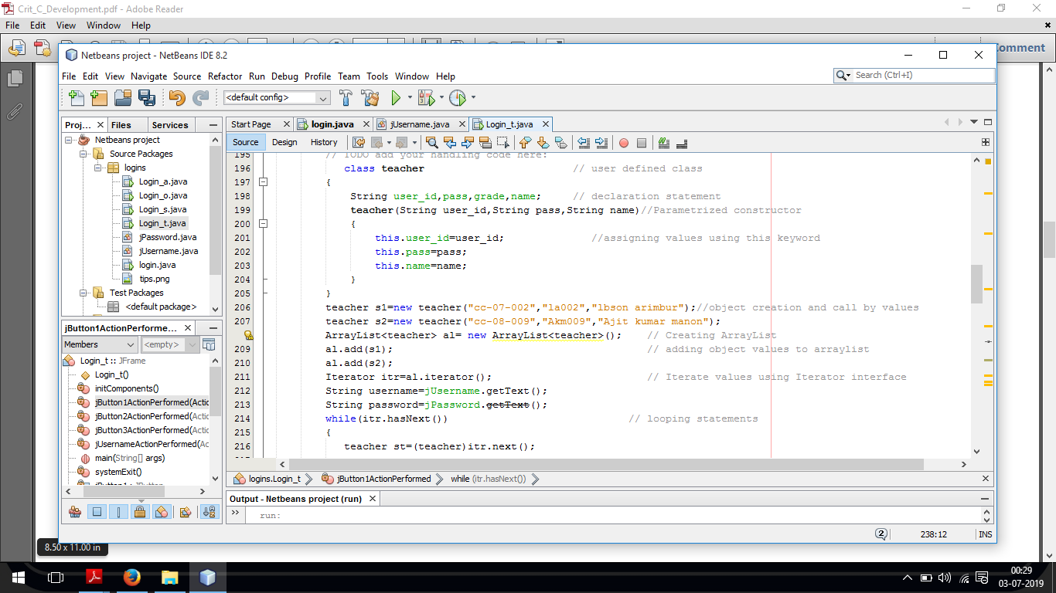

*Figure 2: the screenshot above is a screenshot of part of my programming code where 2 objects are created.*

**SWING UI Elements which were used apart from jtable and jframe:**

jframe : I used jframe to create the layout of all the login pages and to put all the components together.

* joptionpane- it was used to create popup windows which displayed error statements if the entered values were invalid or empty. And also to create user friendly pop up messages once the entered data is successfully registered , modified, added, or deleted.

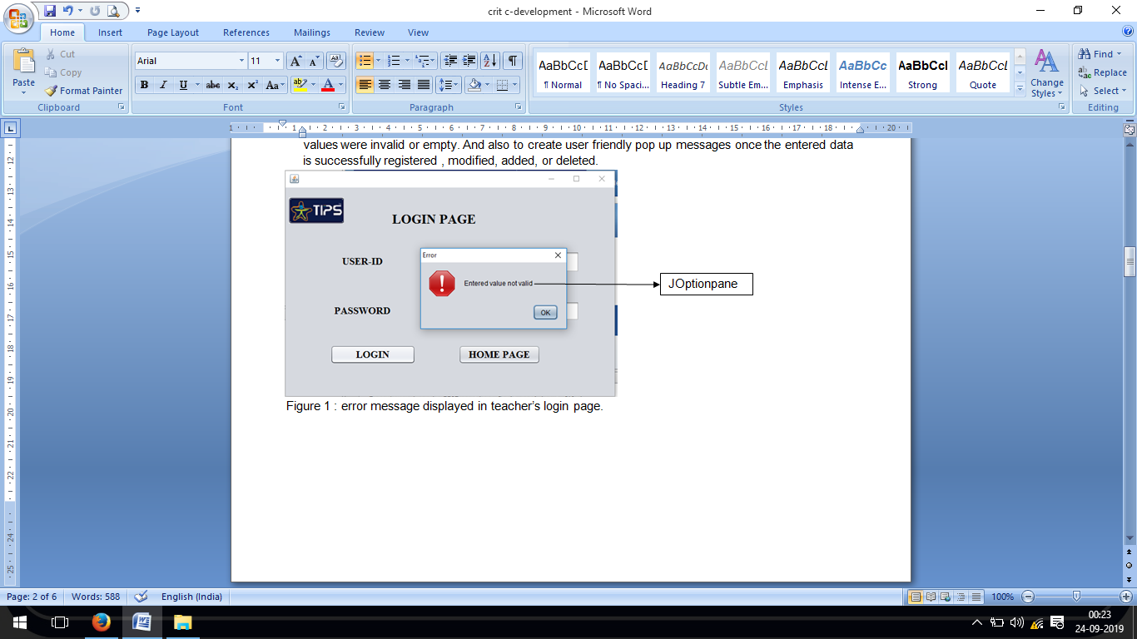

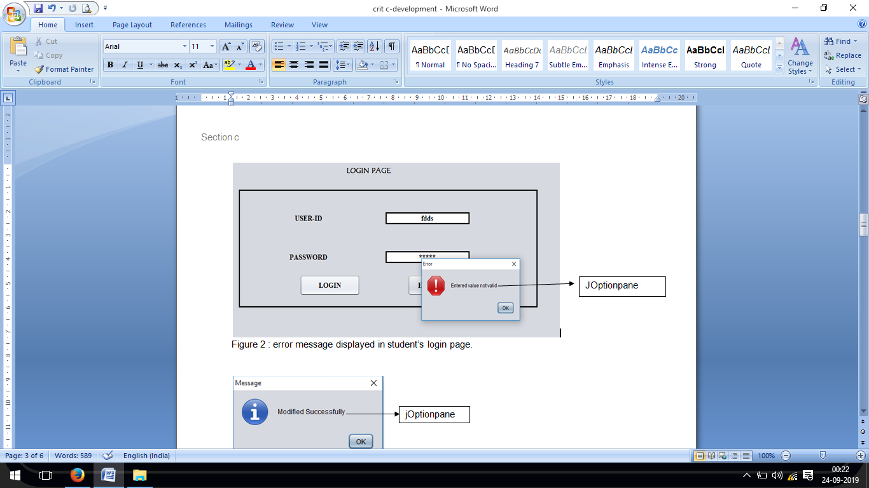

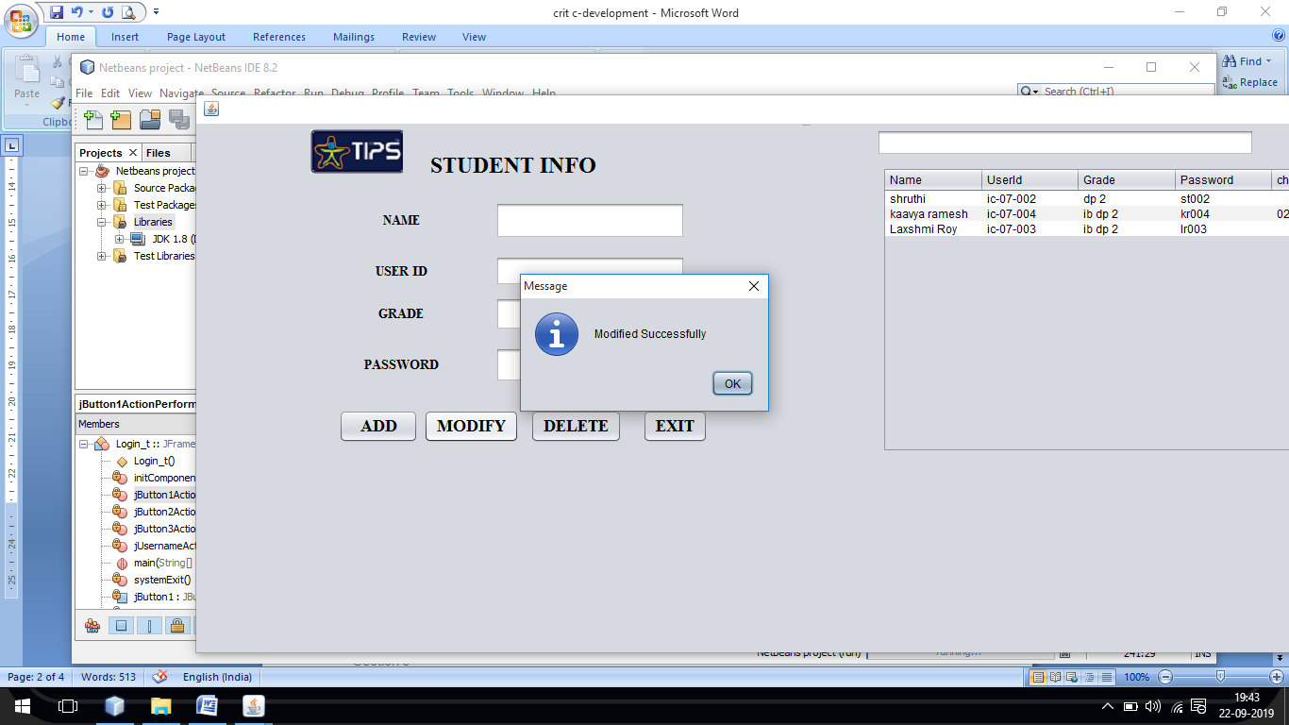

jOptionpane

*Figure 3 : pop up that appears after clicking on modify.*

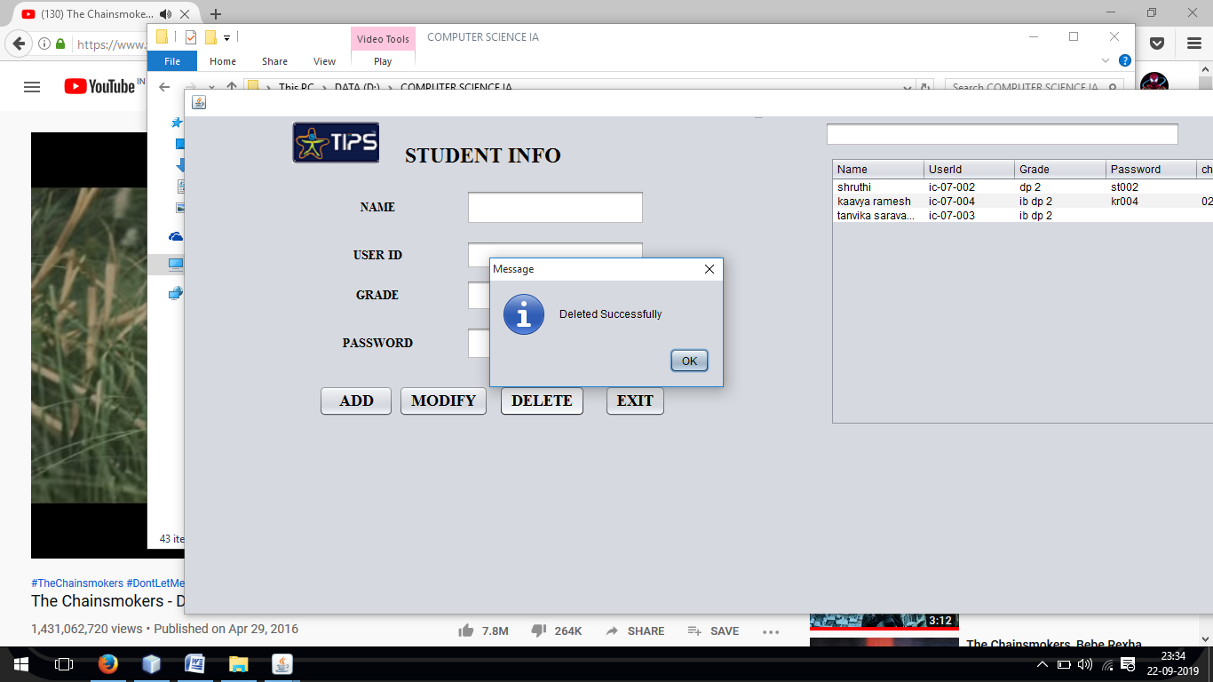

jOptionpane

*Figure 4 : pop up that appears after clicking on delete.*

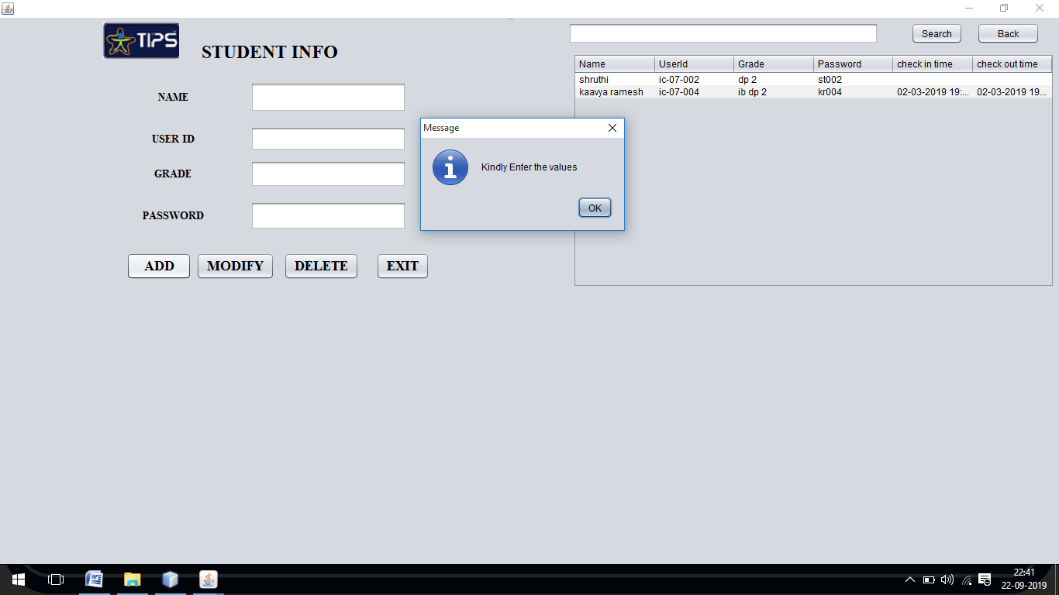

jOptionpane

*Figure 3 : pop up that appears when cells are left blank in the teacher’s page but add option is chosen.*

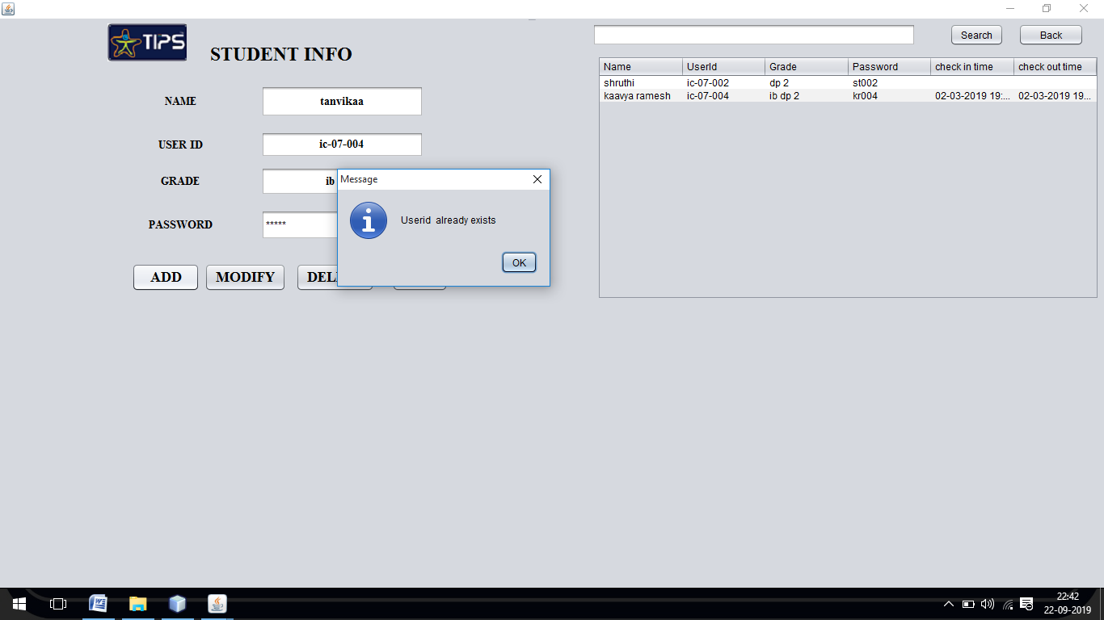

jOptionpane

*Figure 4 : pop up that appears when same user id is entered while entering data for new student account.*

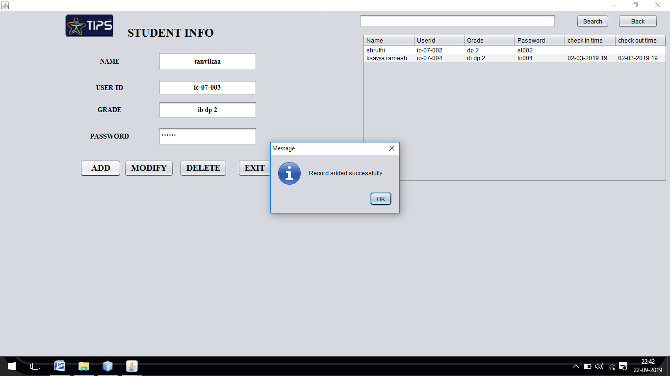

jOptionpane

*Figure 5 : pop up that appears when the new student profile is successfully created with all the newly added data.*

* Jpanel
* jscroll pane-was used to increase the layout size inorder to make large components to be displayed without error or difficulty.
* jbutton- this was used to create buttons like ok,add,delete,check in,check out , exit and all other buttons.
* jlabel : used for displaying titles like login, student info, user id and password. Also in all the pages, the school logo was displayed using jlabel.
* jtextarea : this was used for input cells where the user enters the input information. It was used mostly for entering user id and password in the login pages and for creating input option for student information part in teacher’s page.

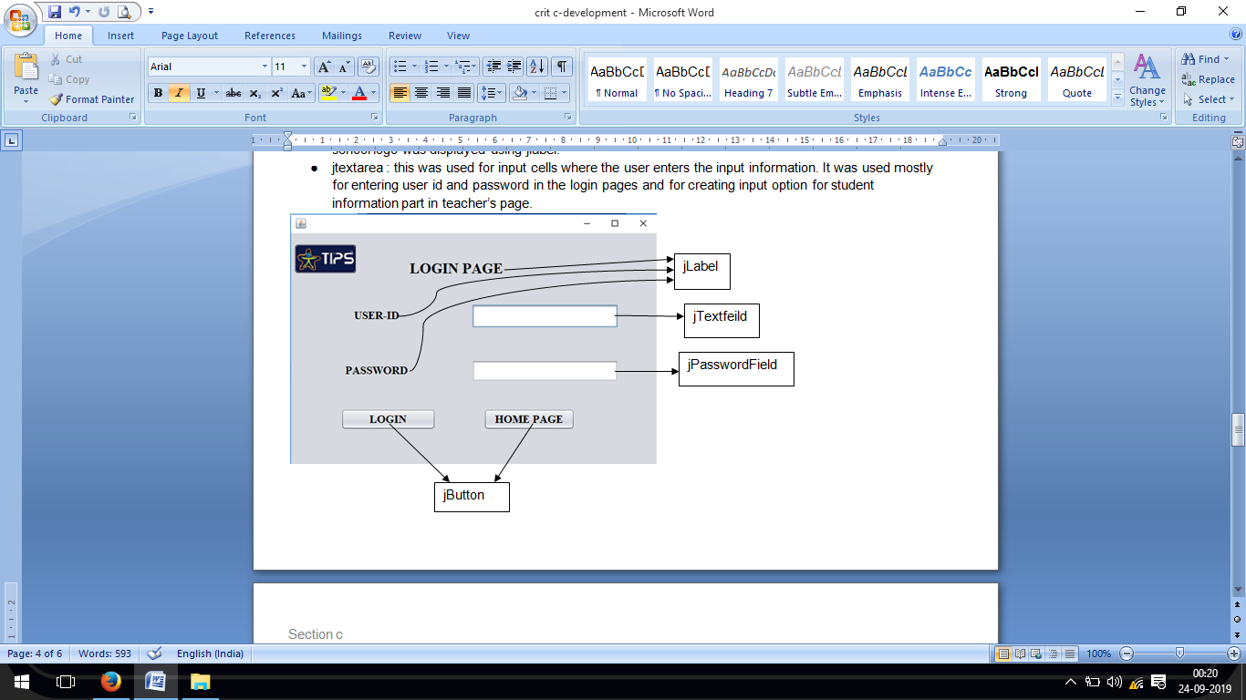

*Figure 6 : Teacher’s login page*

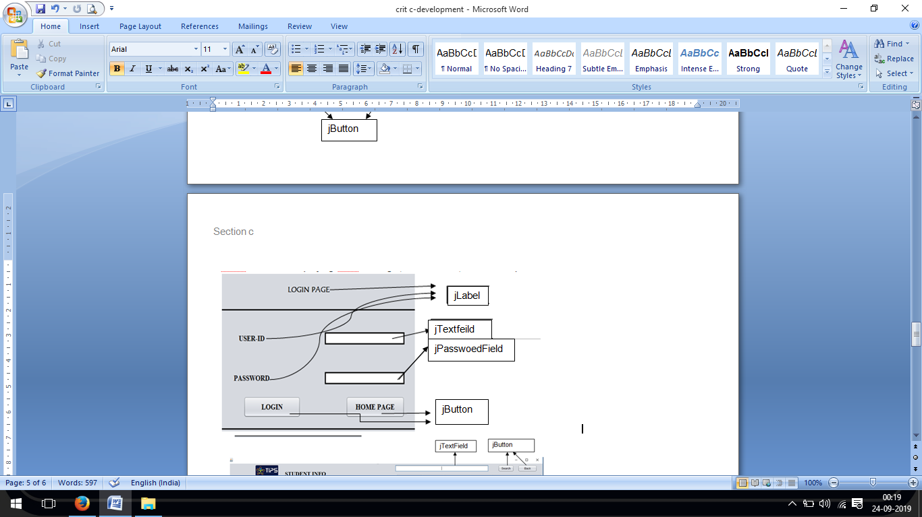

*Figure 7 : student log in page*

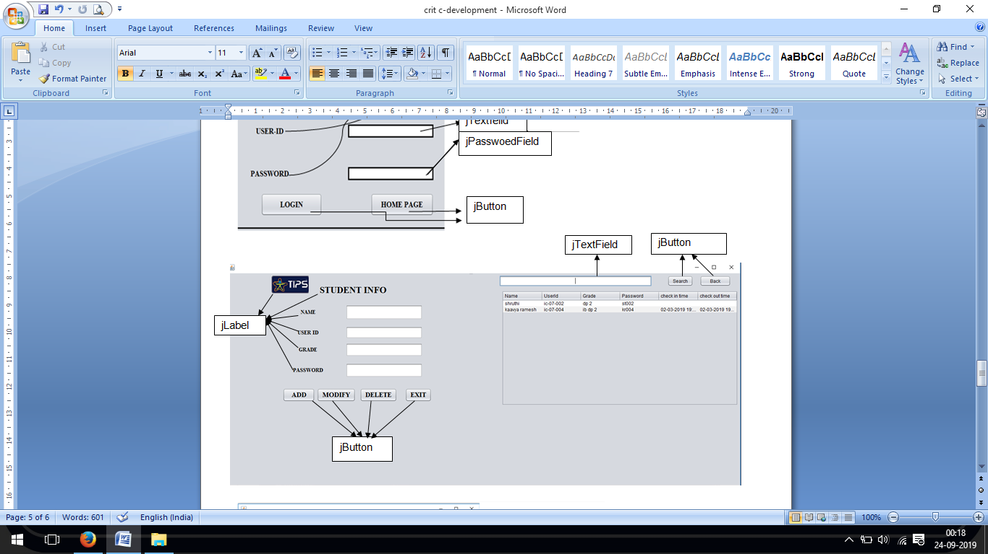

*Figure 8 : teacher’s personal account*

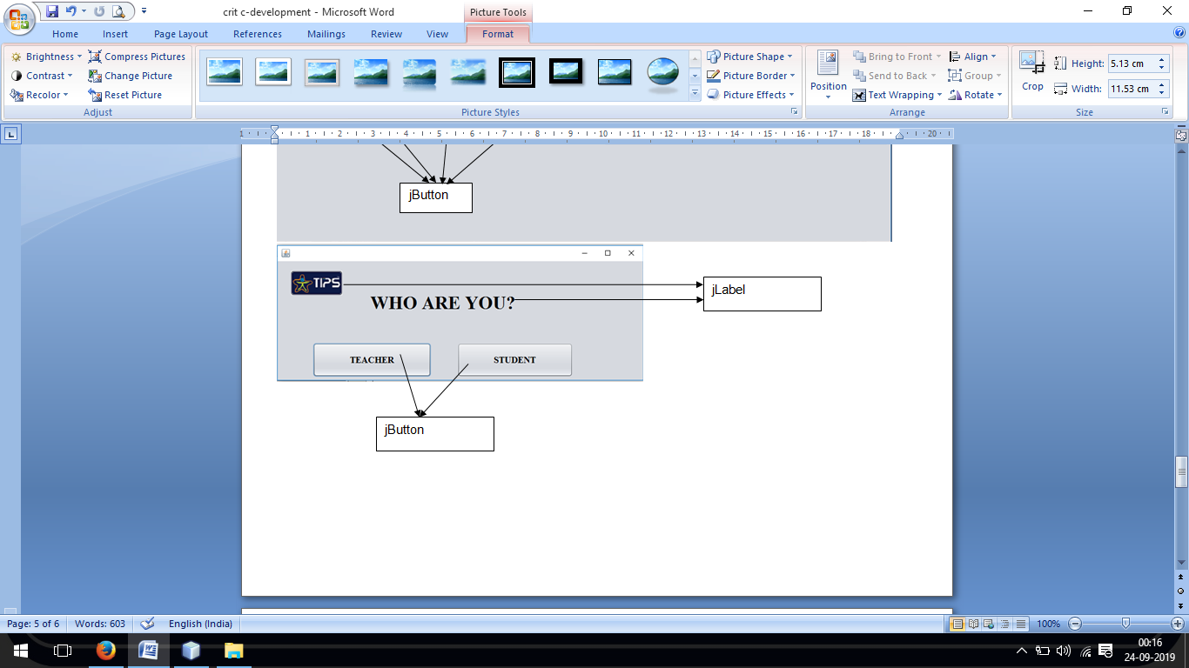

*Figure 9 : The main home page*

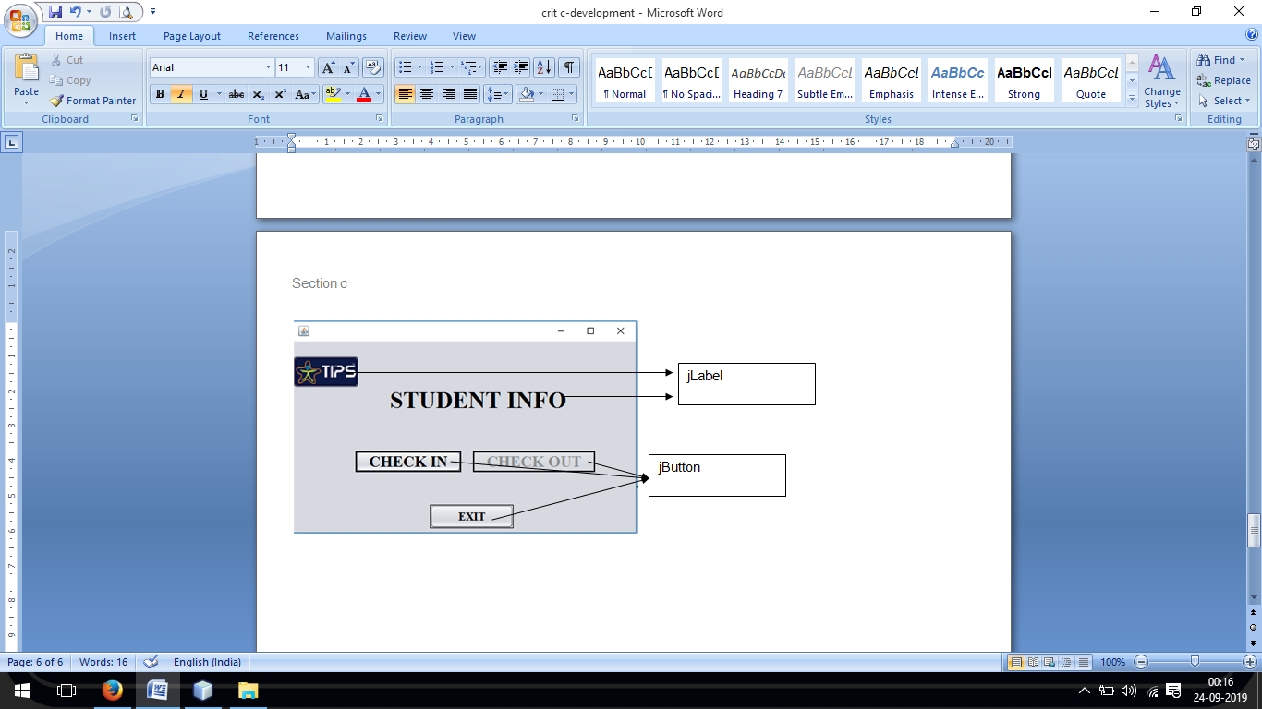

*Figure 10 : student’s personal account*

1. "File System vs. Database - DZone Database." 27 Apr. 2017, <https://dzone.com/articles/which-is-better-saving-files-in-database-or-in-fil>. Accessed 3 Feb. 2019.